Detailed extraction results from various prominent tools

Experimentation Setup :

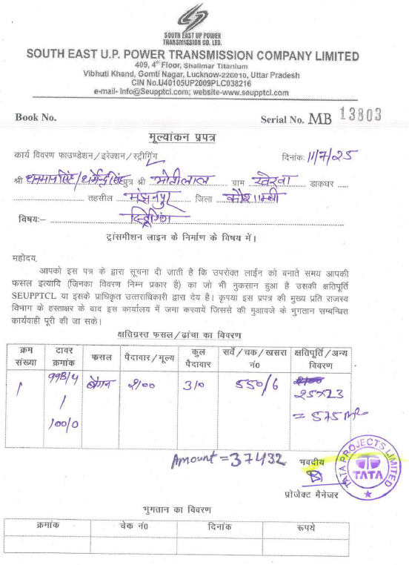
PDF used for extraction

ChatGPT :
---OCR as well as fields extraction both done using chatGPT

Chat link : https://chatgpt.com/share/69244f14-abcc-800f-b8ab-3fea99ddc83a

Results :
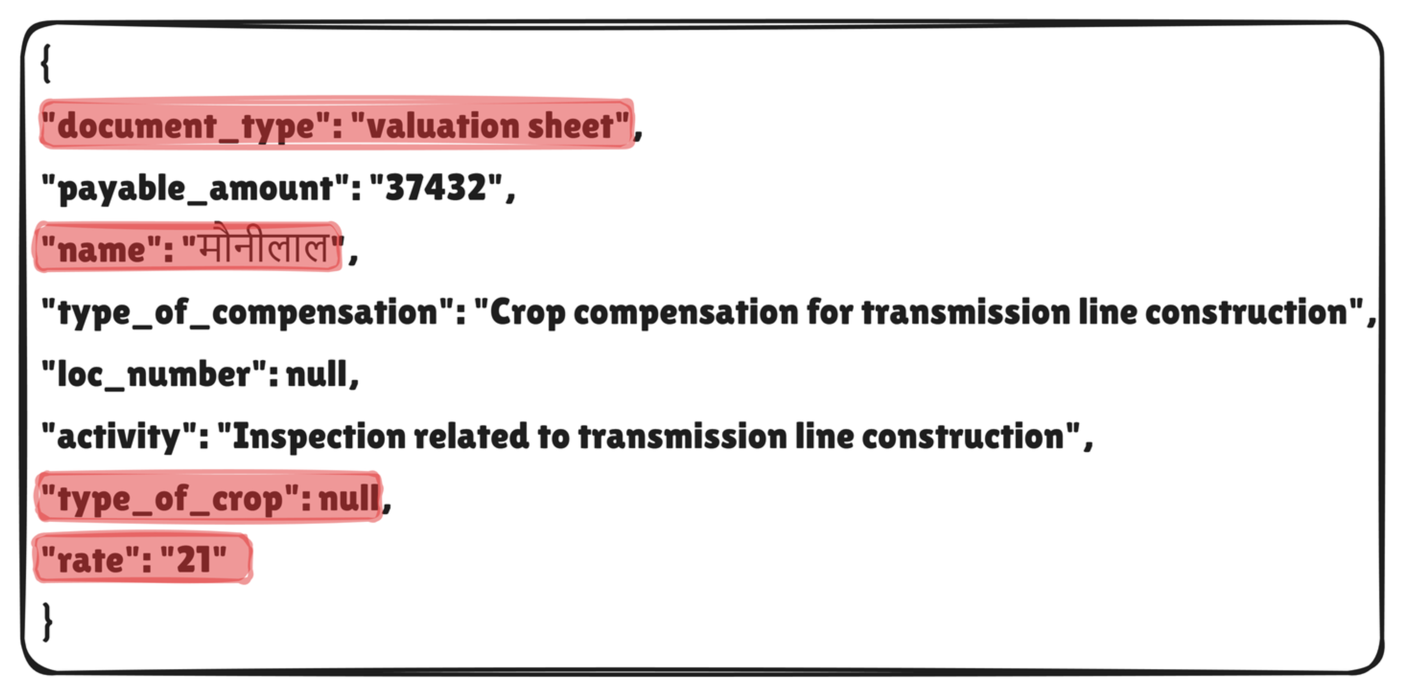

Landing AI’s Agentic Document Extraction :

agentic document extraction link : https://va.landing.ai/share/inference/cotwlhtn2lns9ds9z41xe8yi7

Results :
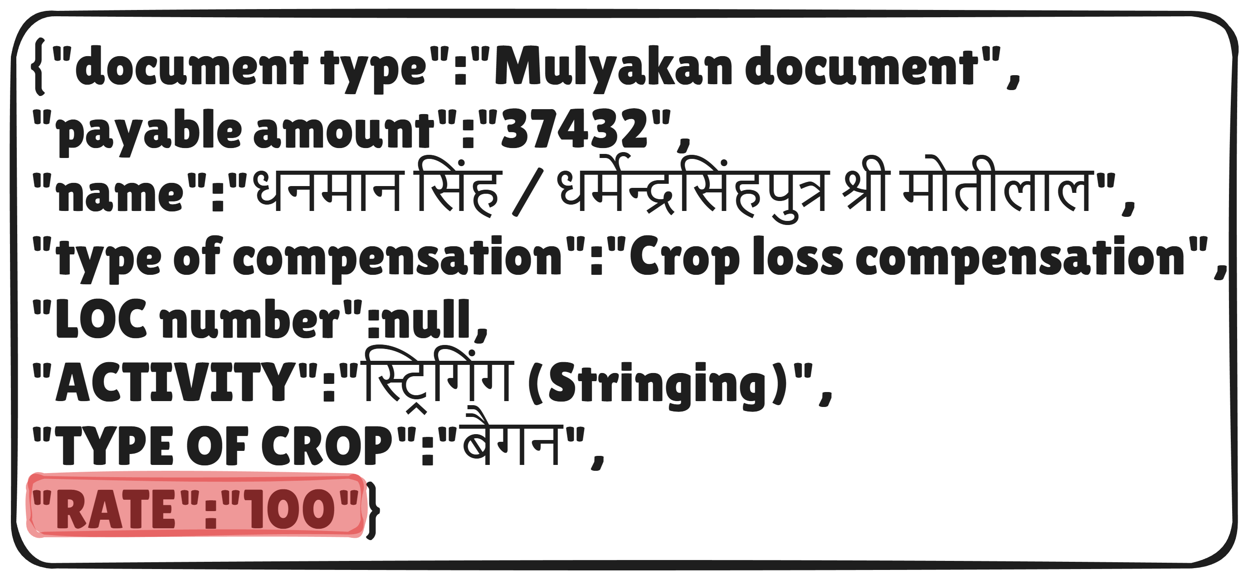

azure content understanding(ai foundary) :

---pdf OCR using Microsoft Azure-content understanding(Microsoft ai foundary)

OCR text link : https://drive.google.com/file/d/1M5DgqWXHOAUNwwbCJ3NfcGPZDMoMW_Cw/view?usp=sharing

---Fields extraction by passing the OCR text into ChatGPT(5.1 Thinking)

Results :
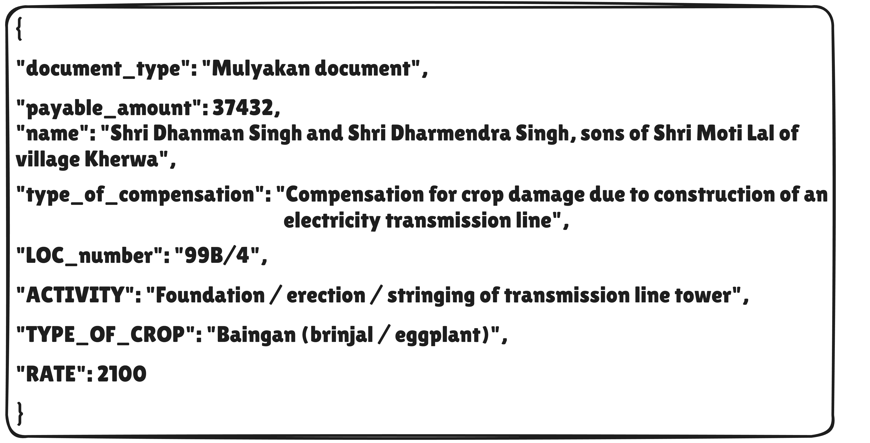
---Fields extraction by passing the OCR text into Gemini(Thinking with 3 pro)

Results :
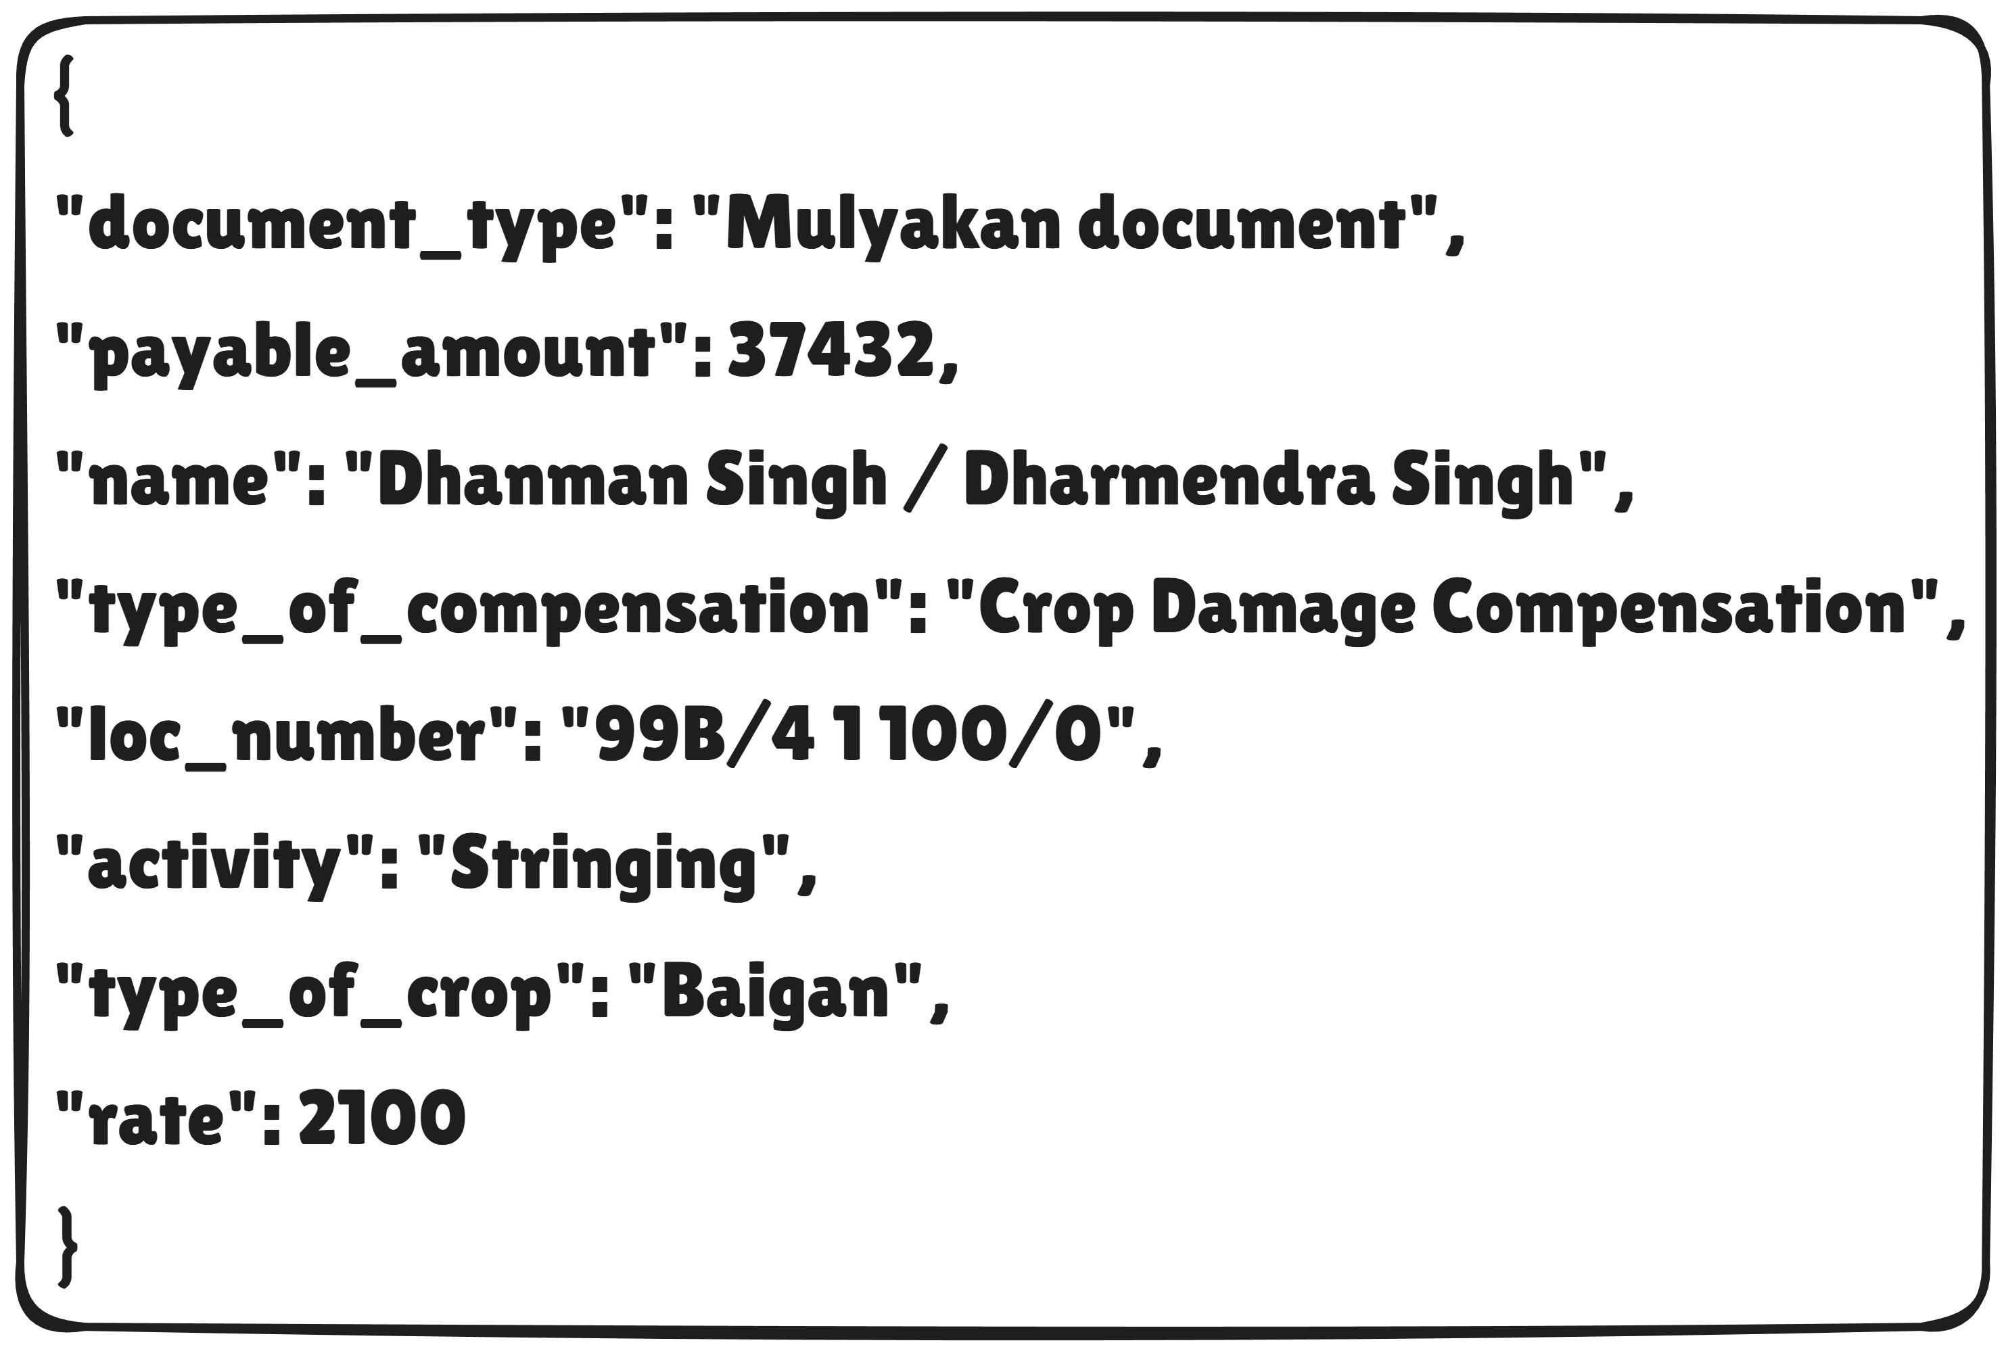

azure document intelligence(OCR) :

---pdf OCR using Microsoft Azure-document intelligence studio(OCR)

OCR text link : https://drive.google.com/file/d/1UpiU6DEaIdcqVZpv01VoEZms05ogylWP/view?usp=sharing

---Fields extraction by passing the OCR text into ChatGPT(5.1 Thinking)

Results :
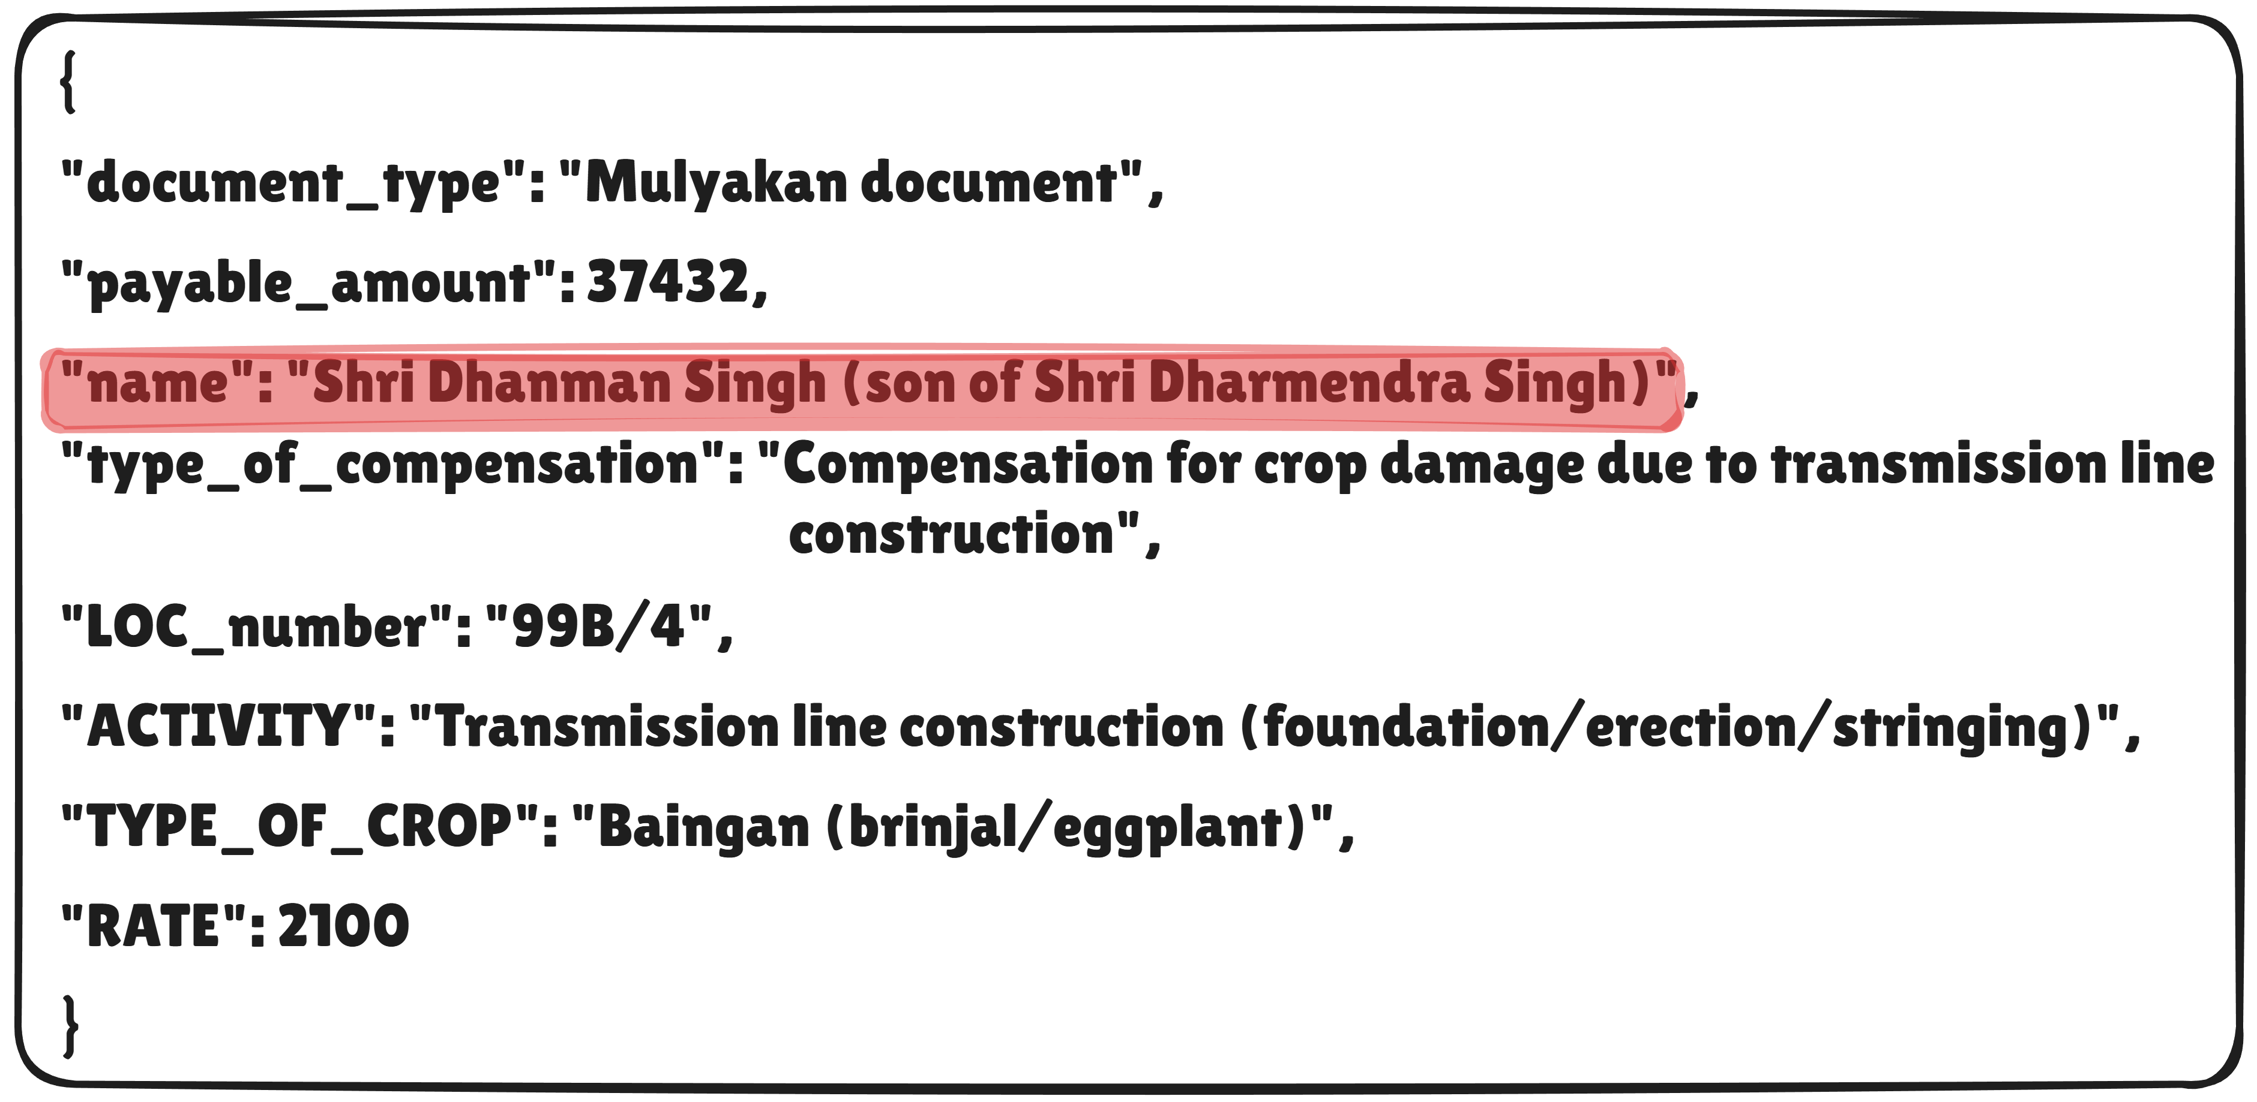
---Fields extraction by passing the OCR text into Gemini(Thinking with 3 pro)

Results:
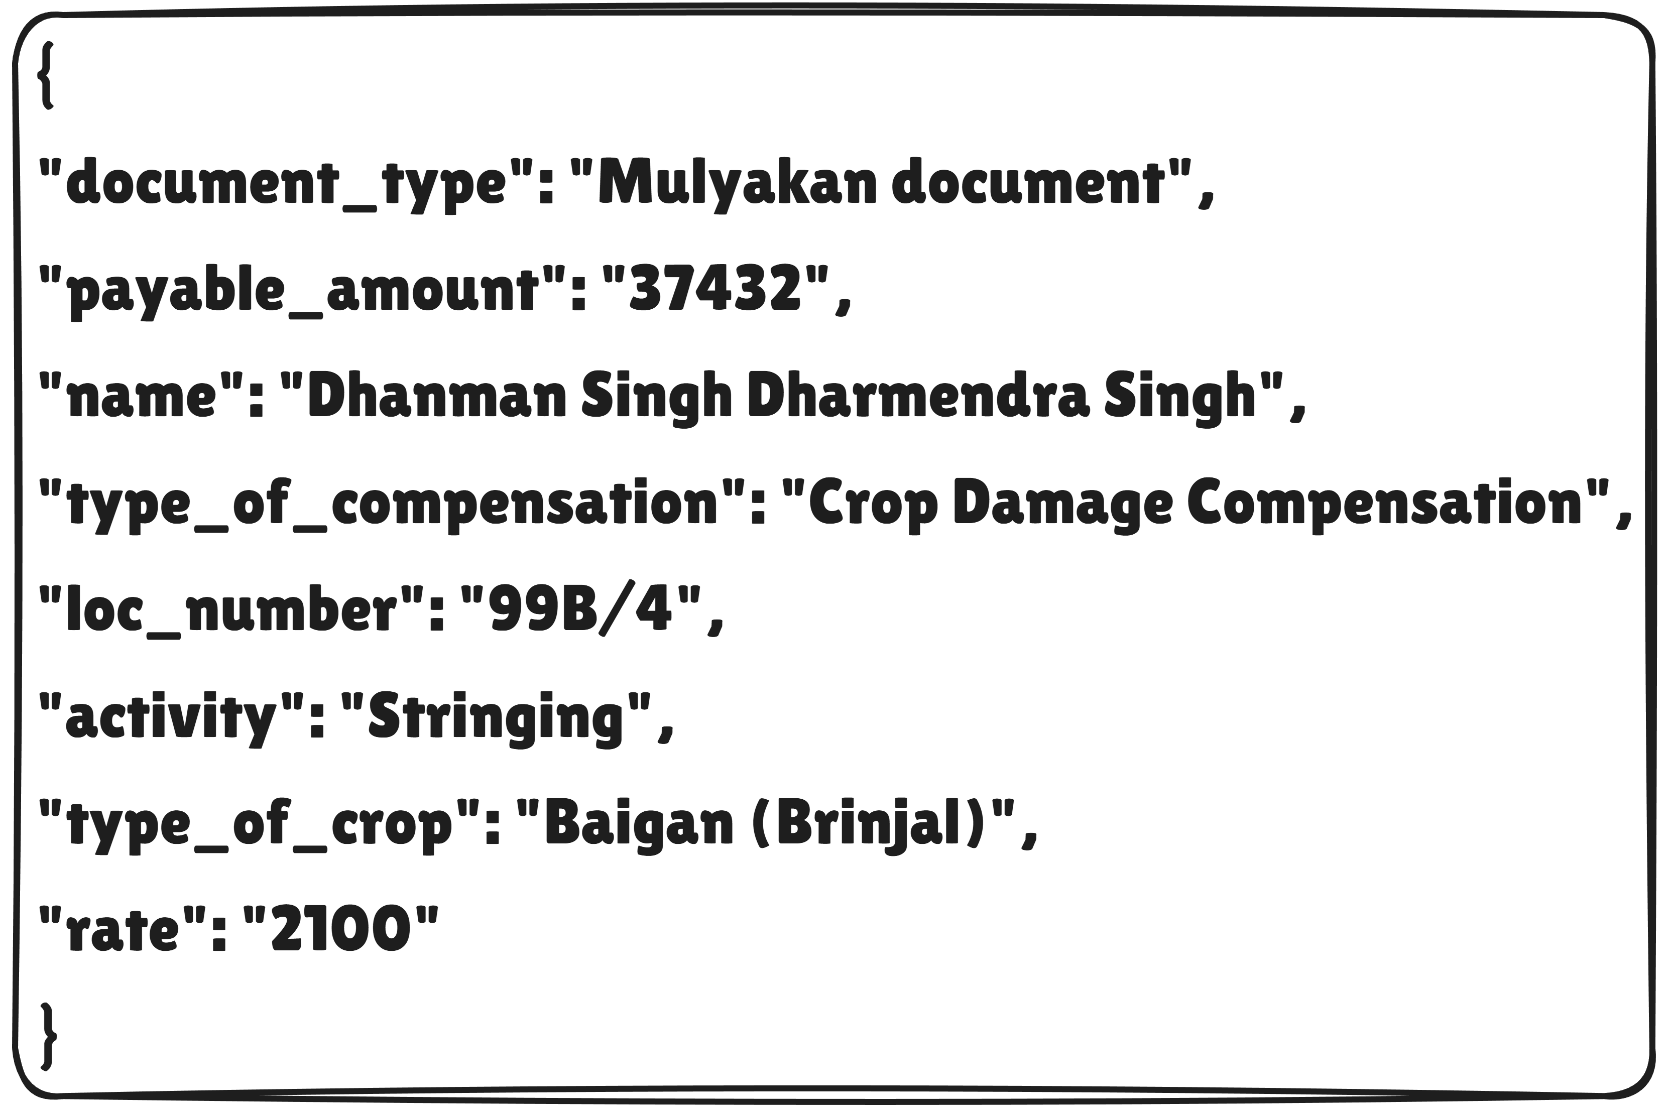
Gemini :
---OCR as well as fields extraction both done using Gemini

Chat link : https://gemini.google.com/share/42ff6db30fbe

Results :
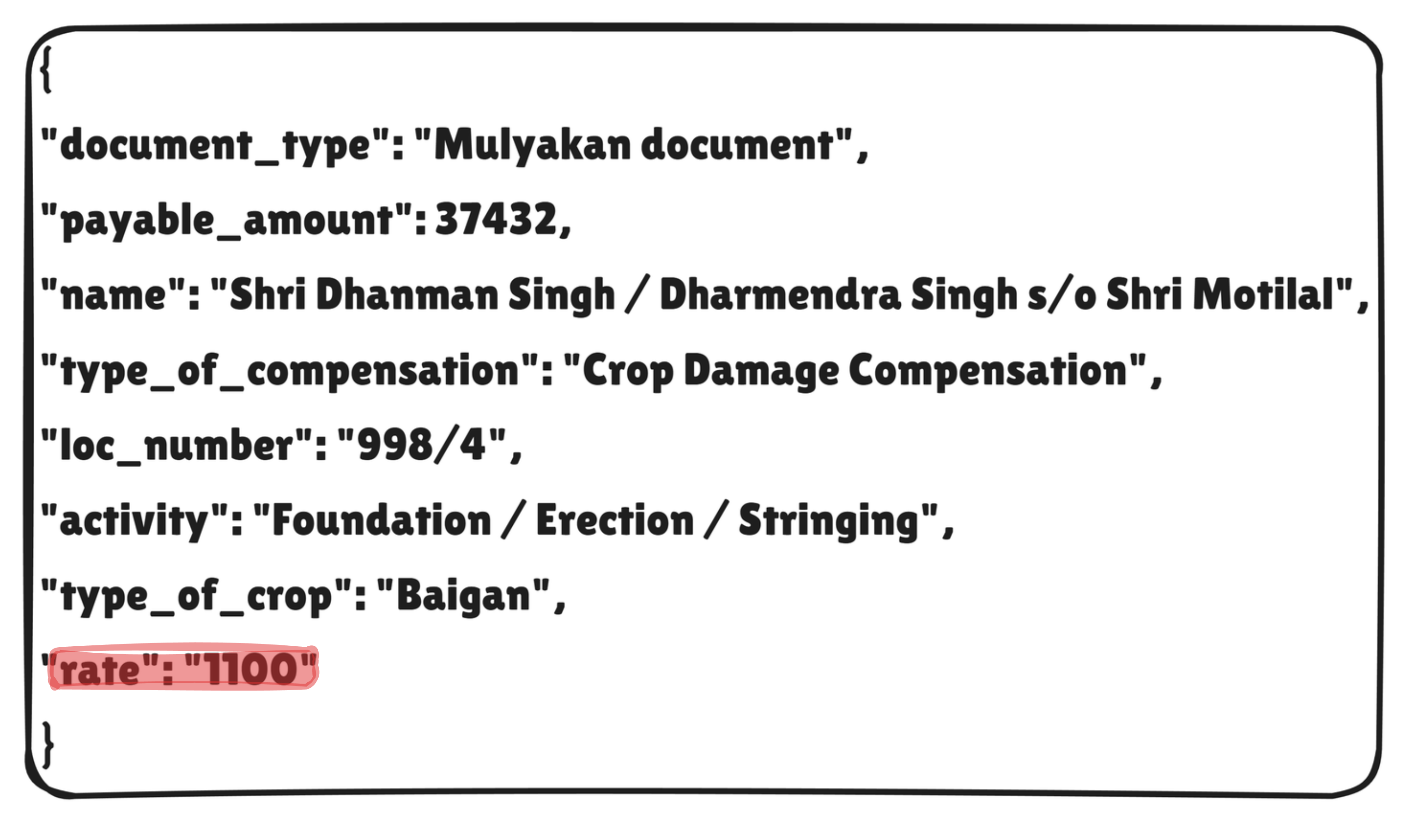

PRY Extraction :
---OCR done using PRY with out selecting ‘include’ option

OCR text link : https://drive.google.com/file/d/1ITa6RWhpBXri2nZ6DbUfBU_wY-xpxR-y/view?usp=sharing

---Field extraction passing OCR text to ChatGPT(5.1 Thinking)

Results :
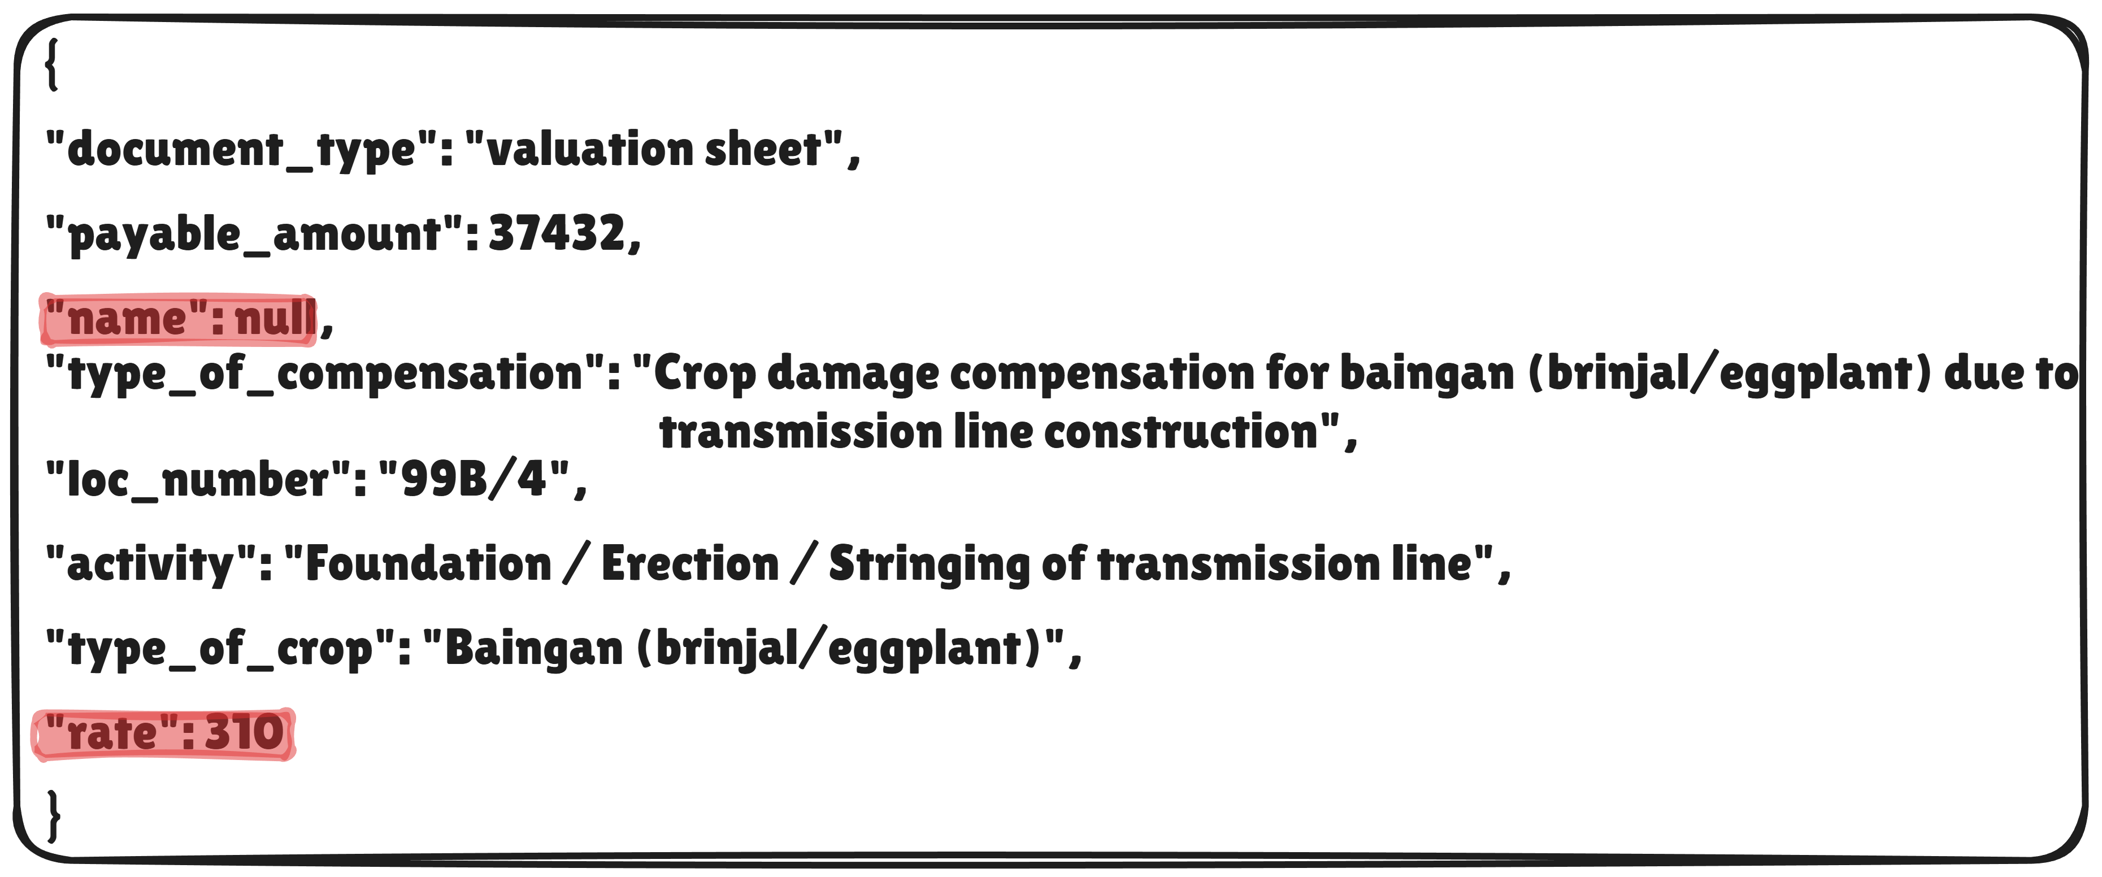

---Field extraction passing OCR text to Gemini(Thinking with 3 pro)

Results :
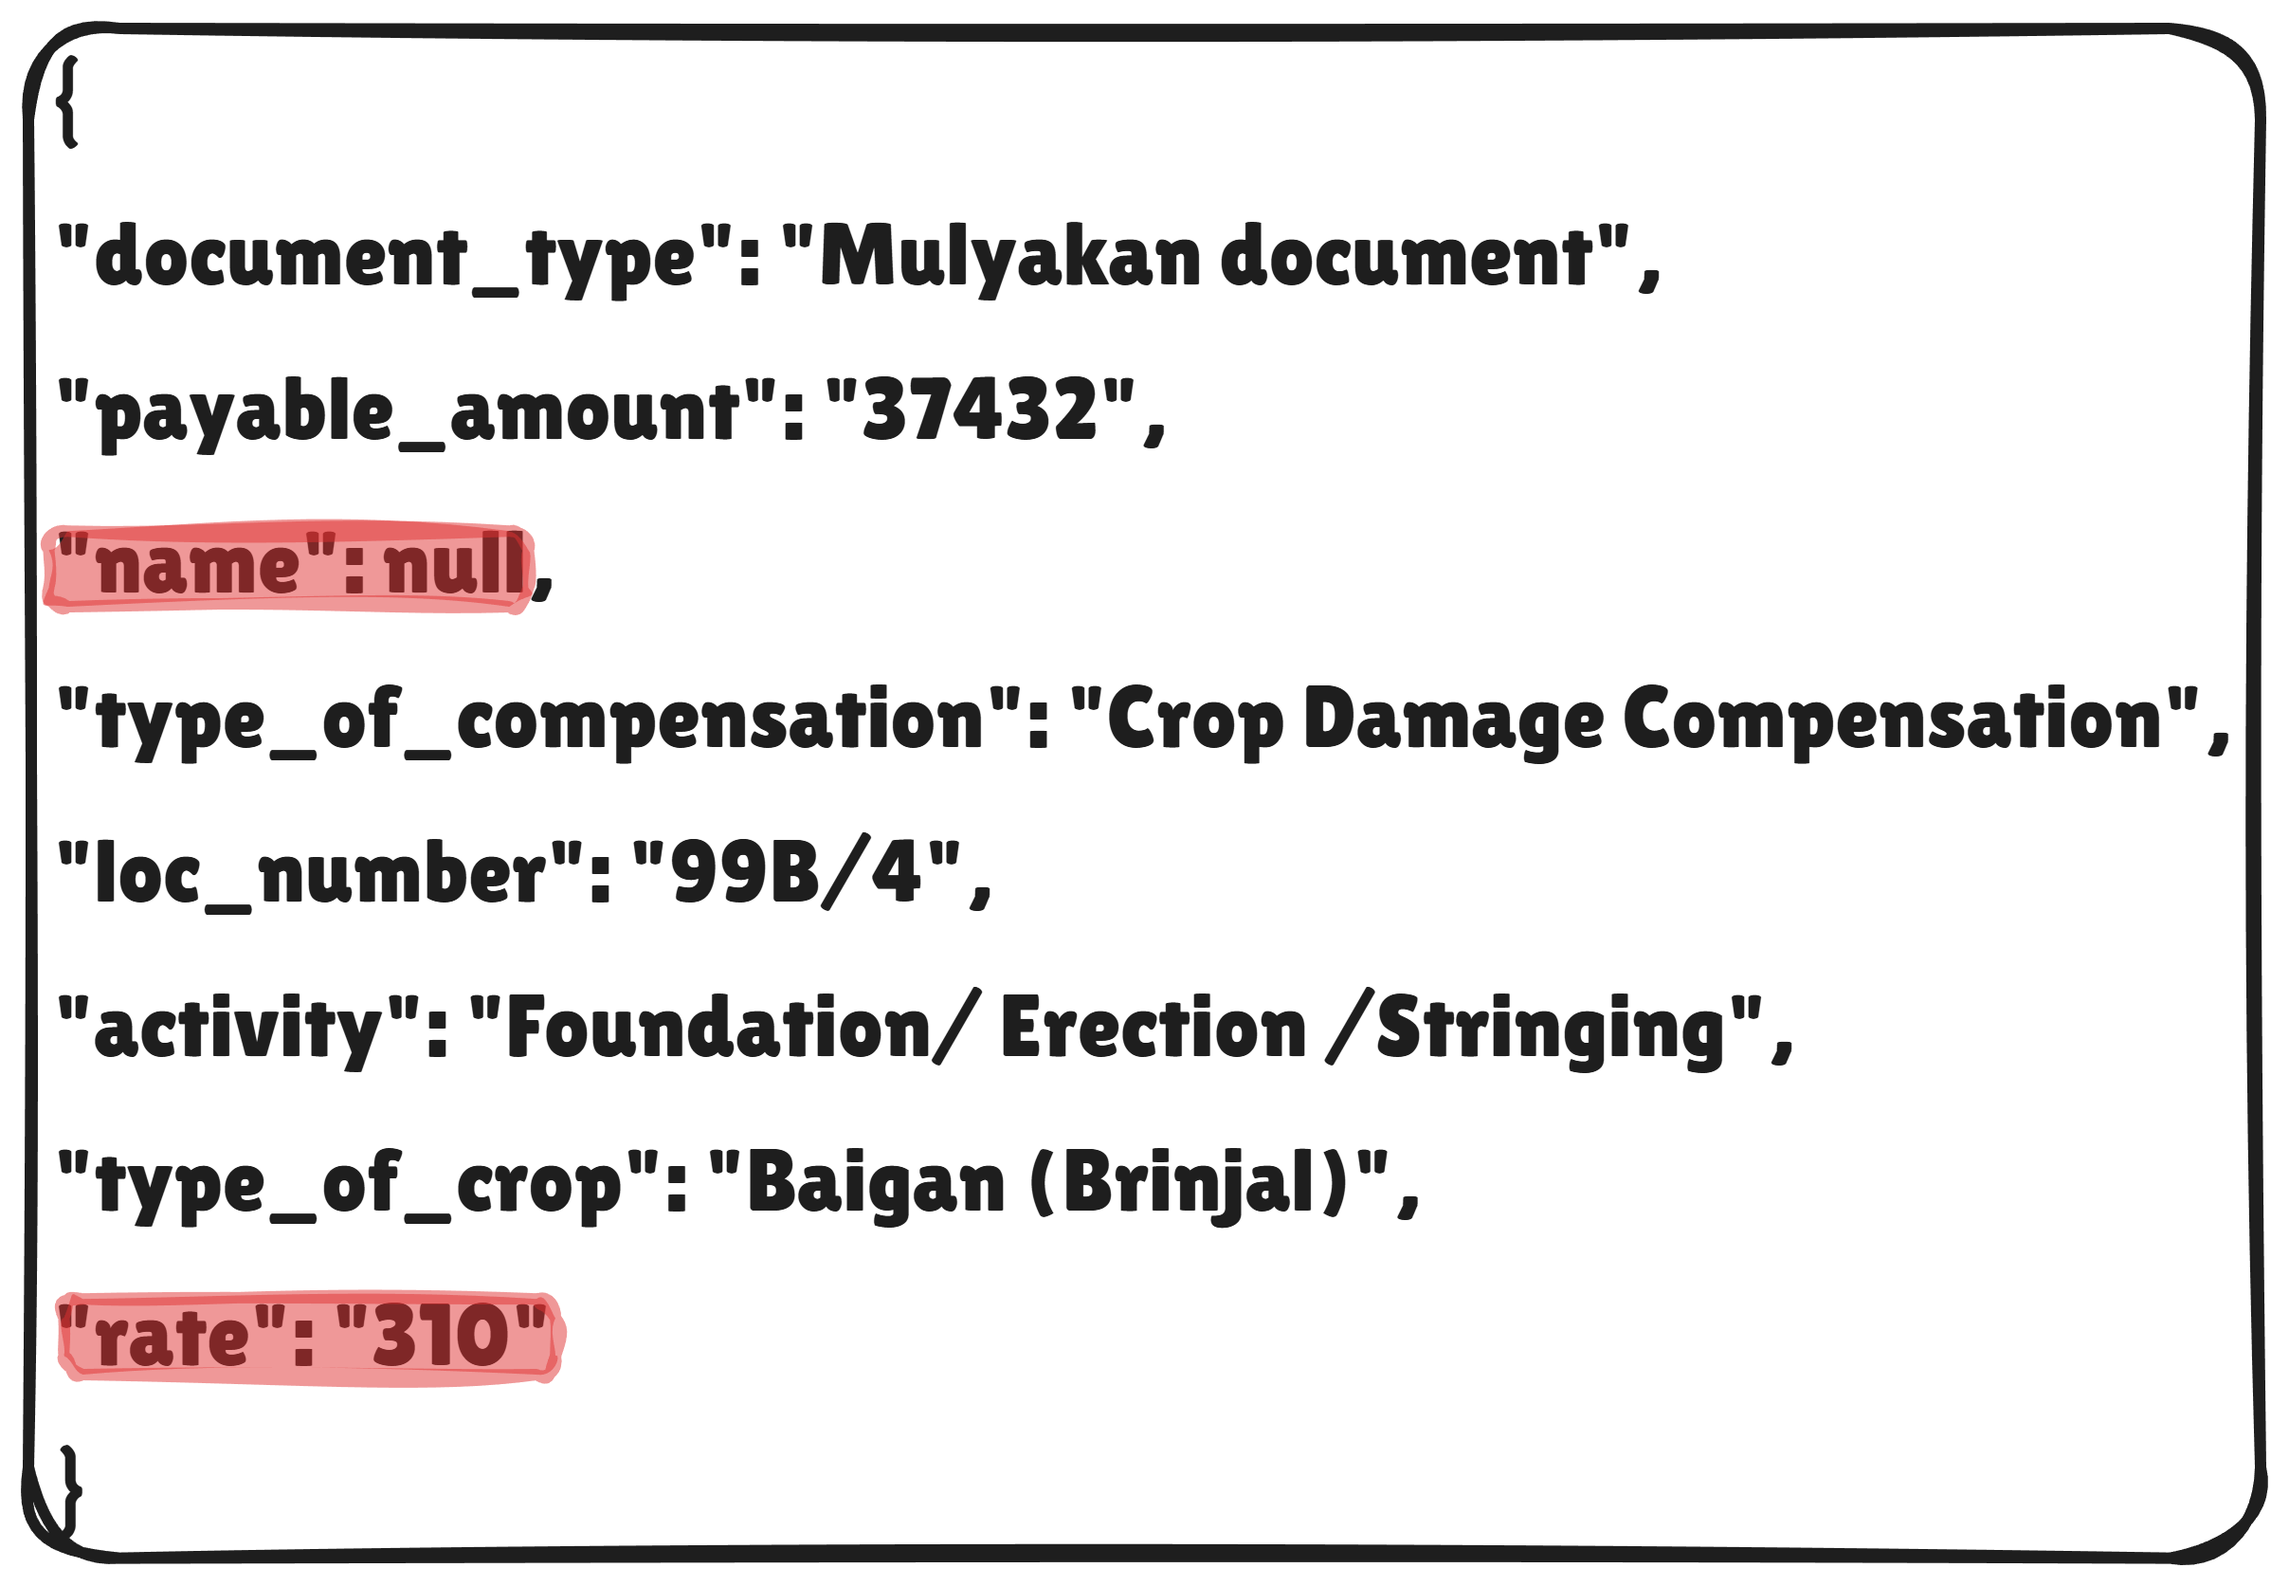

PRY Extraction (include tabels in OCR text):
---OCR done using PRY with selecting ‘include’ option

OCR text link : https://drive.google.com/file/d/1ITa6RWhpBXri2nZ6DbUfBU_wY-xpxR-y/view?usp=sharing

---Field extraction by passing OCR text to ChatGPT(5.1 Thinking)

Results :
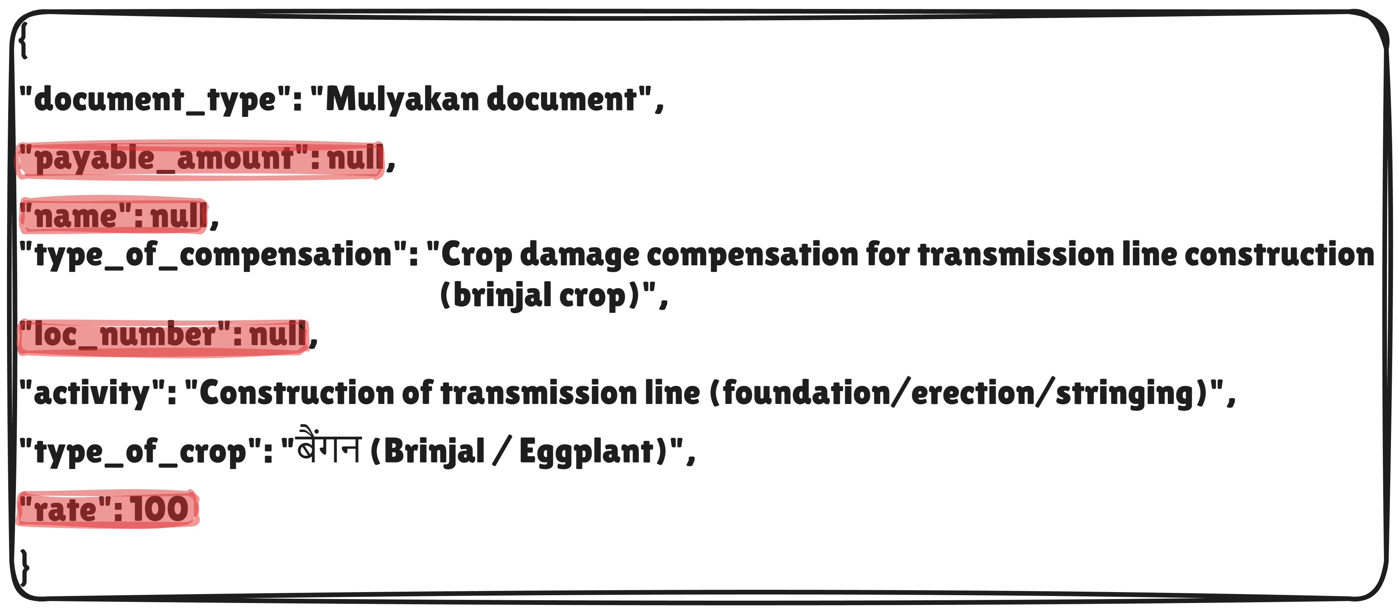

---Field extraction by passing OCR text to Gemini(Thinking with 3 pro)

Results :
